Code Review: I2301011
Reviewer: Mark Dell
Date: May 15th, 2023

Bugs

Preventative Action/Safety

Design/Architecture (Duplication, appropriate project, namespaces, maintainability)

Data Model (Naming, good design, needs index?)

Performance (Minimize DB hits, excessive loops, queries, scalable)

UI (Alignment, naming, standardization, tab order)

Error Handling (Behind events, appropriate parameter checking)

Cleanup (Dispose code, remove handlers, large data objects)

* Readability (Well-named variables, methods, clear algorithm, is it understandable)
- Nit: I recommend consistency in expressions when used for the same purpose. In this case the If statements that use “> 0” and “<> 0”. Having a difference may cause some to wonder if there was a reason for that. I specifically prefer “<> 0” when the sign is not meaningful, but consistency is more important (lines 1007 vs 1014).
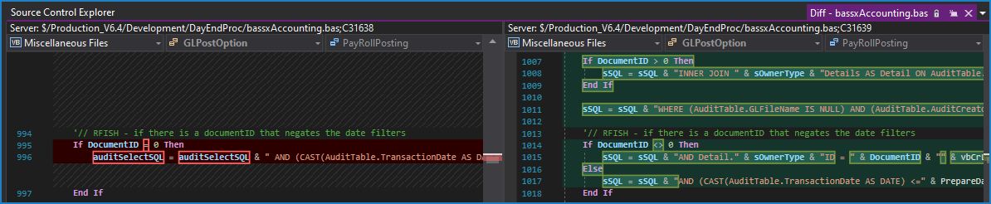

Comments (Useful, explains why rather than how)

Message Boxes (Grammar, spelling, captions, appropriate icons)

Ticket Management (Release Branch?, Testing Notes)

* Extras
- Nit: When modifying code, we rarely comment out the old code anymore (line 992-997). Instead, we just remove it, and some will put a reference to the ticket number that it was modified for.
Keeping the old code is partly a holdover from before we had TFS, and it has been decided that it is no longer warranted. TFS should help us enough that we don’t need to keep a bunch of old, commented out code lying around our codebase.
